**LAB MANUAL # 5**

**HOME TASK**

**HAMZA SAIF**

**481070**

//task#1

#include<iostream>

using namespace std;

int main(){

//HCF is highest common factor

//LCM is lowest common multiple

int num1, num2, product ;

cout << "Enter the first number: ";

cin >> num1;

cout << "Enter the second number: ";

cin >> num2;

product = num1 * num2;

//using while loop

//product of both numbers must not be zero

//use if condition after while loop

while(product != 0){

if(product % num2 == 0){

cout << "HCF of " << num1 << " and " << num2 << " is " << product << endl;

break;

}

//if the above case is not fulfilled the else command is executed

else{

product = product * num2;}

}

// In the end we find lcm using mathematical operators

int lcm = (num1 * num2) / product;

cout << "LCM of " << num1 << " and " << num2 << " is " << lcm << endl;

return 0;

}

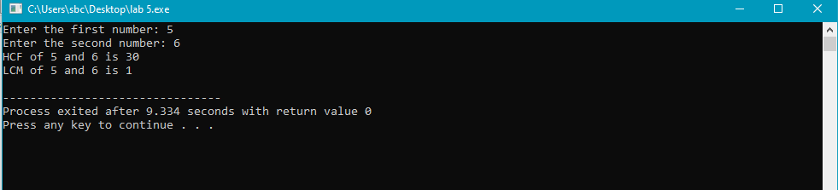

//task#2

#include<iostream>

using namespace std;

int main(){

// ARTHMETIC SERIES

// first term a

// number of terms n

// common difference d

int n, a , d , sum=0 ;

cout << "Enter the number of terms in the series: ";

cin >> n;

cout << "Enter the first term of the series: ";

cin >> a;

cout << "Enter the common difference of the series: ";

cin >> d;

// in general the formula for addition is SUM = n / 2 ( a + (n-1) d )

for (int i = 0; i < n; i++){

sum += a + (i * d);

}

cout << "The sum of the series is: " << sum << endl;

return 0;

}

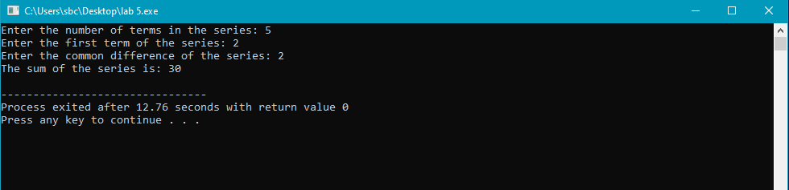

//task#3

#include <iostream>

using namespace std;

int main(){

// total number of rows n for pyramid no 1

// for pyramid no 2 , no of rows is (n-1)

// number of line is i

// for spacing (i-1) ,, let say line is i=1 the no of spacings before * is 4

int i , j , n , space = 1;

cout << "Enter the number of rows :" <<endl;

cin >> n ;

space = n - 1;

//for first pyramid we do decrement in spacing

//for second pyramid we do increment in spacing

for ( i = 1; i <= n; i++)

{

for ( j = 1; j <= space; j++){

cout << " ";

}

space--;

for ( j = 1; j <= 2*i-1 ; j++){

cout << "*";

}

cout << endl ;

}

space = 1;

for ( i = 1 ; i <= n-1 ; i++)

{

for ( j = 1; j <= space; j++){

cout << " ";

}

space++;

for ( j = 1; j <= 2*(n-i)-1 ; j++){

cout << "*" ;

}

cout << endl;

}

return 0;

}

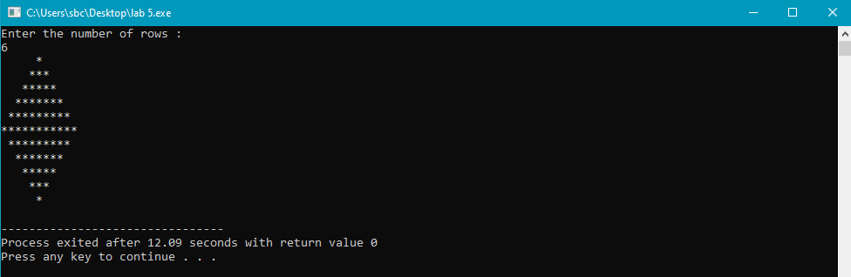

//task#4

#include <iostream>

using namespace std;

int main(){

// the decimal number is n

// a binary number is in the form of 1 0 so we make conditions such that we get remainder 1,0

// we set the range between 1 0 so we get number in binary

int a[10] , n, i;

cout<<"Enter the number to convert: ";

cin>>n;

for(i=0; n>0; i++){

a[i]= n%2;

n= n/2;

}

cout<<"Binary of the given number= ";

for(i=i-1 ;i>=0 ;i--){

cout<< a[i] ;

}

return 0;

}

